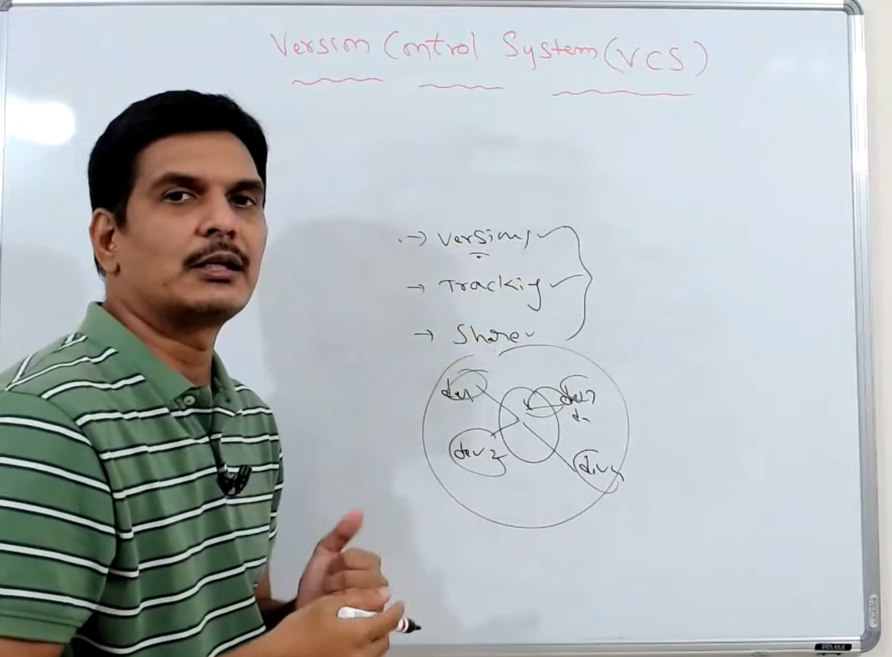

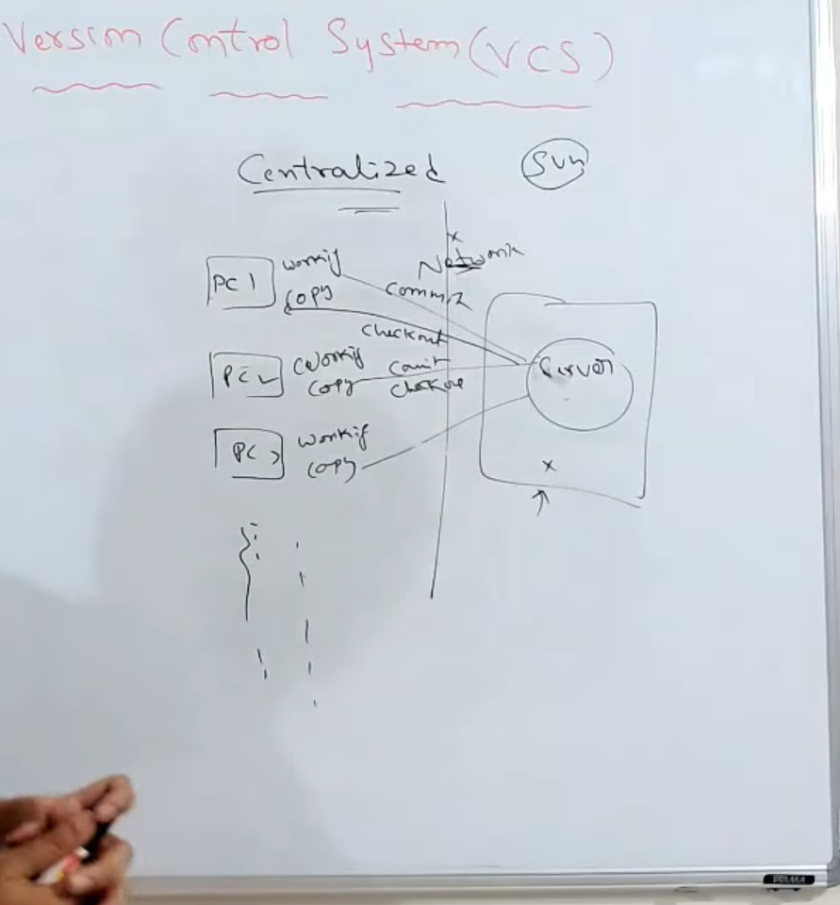

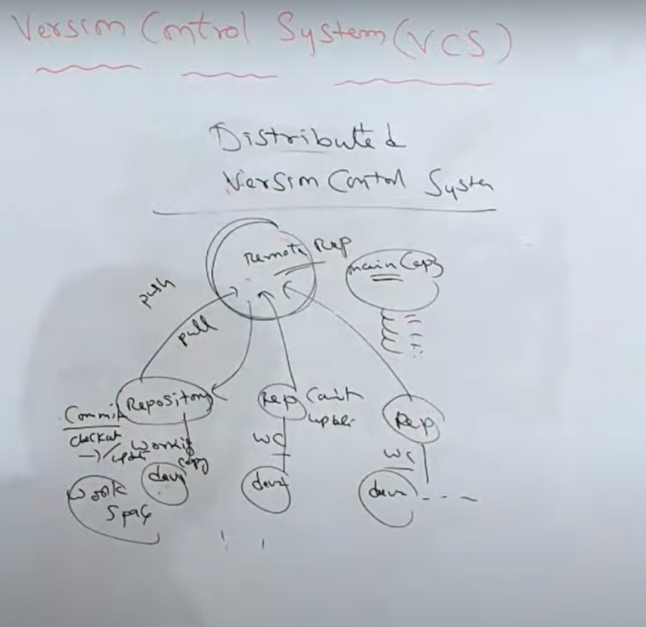

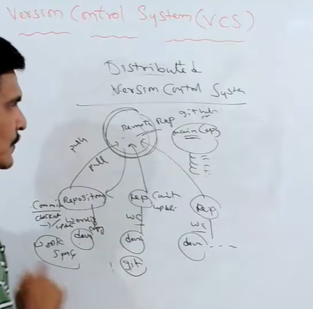

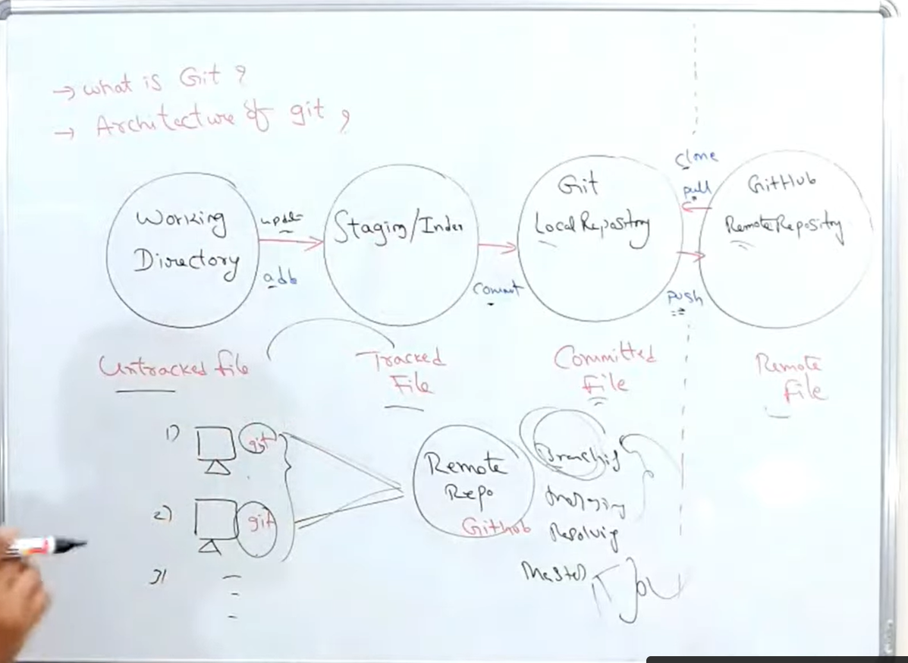

Git Commands

1. init : it will create new empty local repository.
2. status : shows the status of the files, like which is tracked or un-tracked or committed and so on.
3. add : it will add all files to staging area
4. commit : it will commit all the changes into your local repository.
5. log : it will show you how many times you committed your files.
6. config : we will execute this command only once to configure your email id and your username for git.

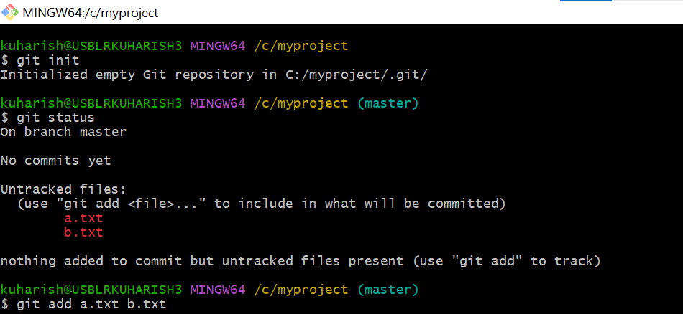

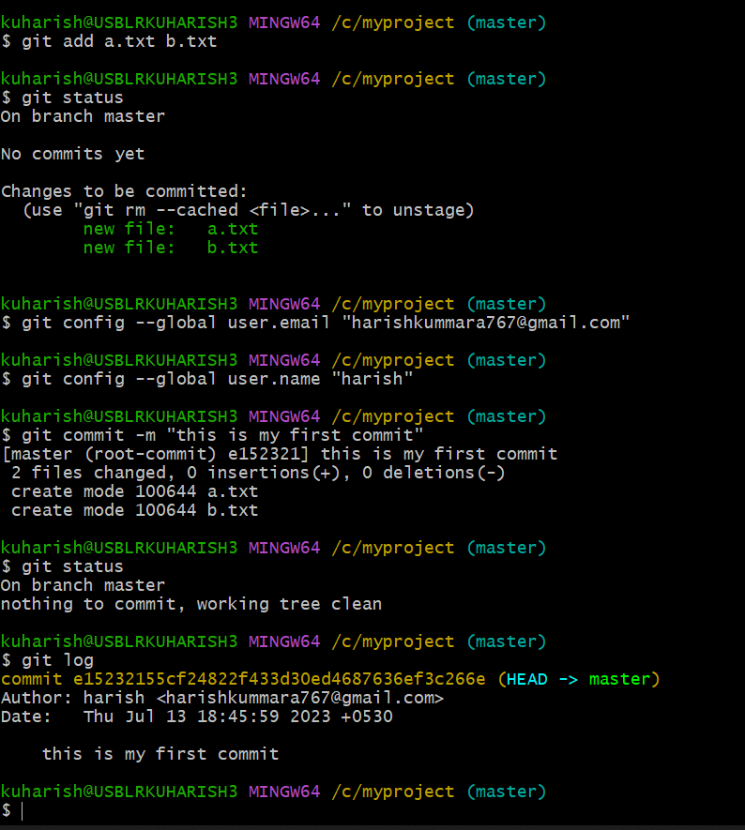

After modification in your files

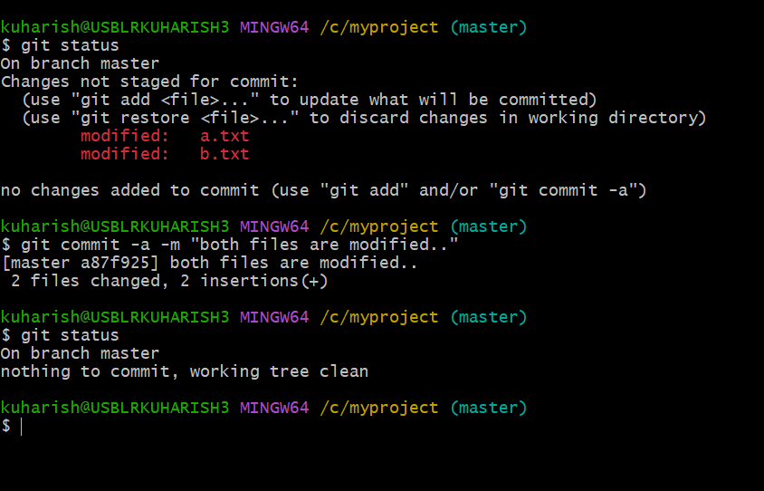

Git diff : it is used to comparing the files in version control system

b/w working dir , staging, local repo, remote repo

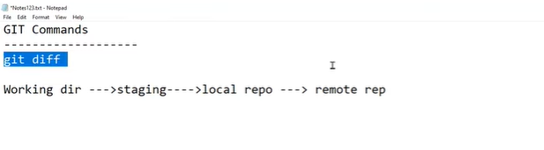

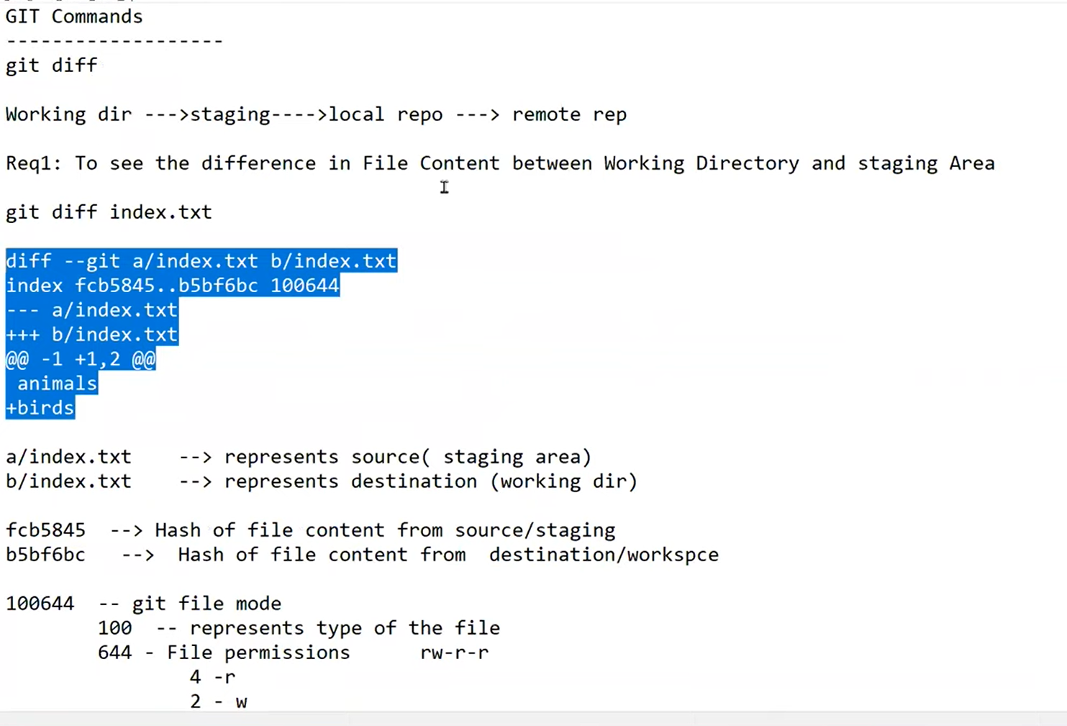

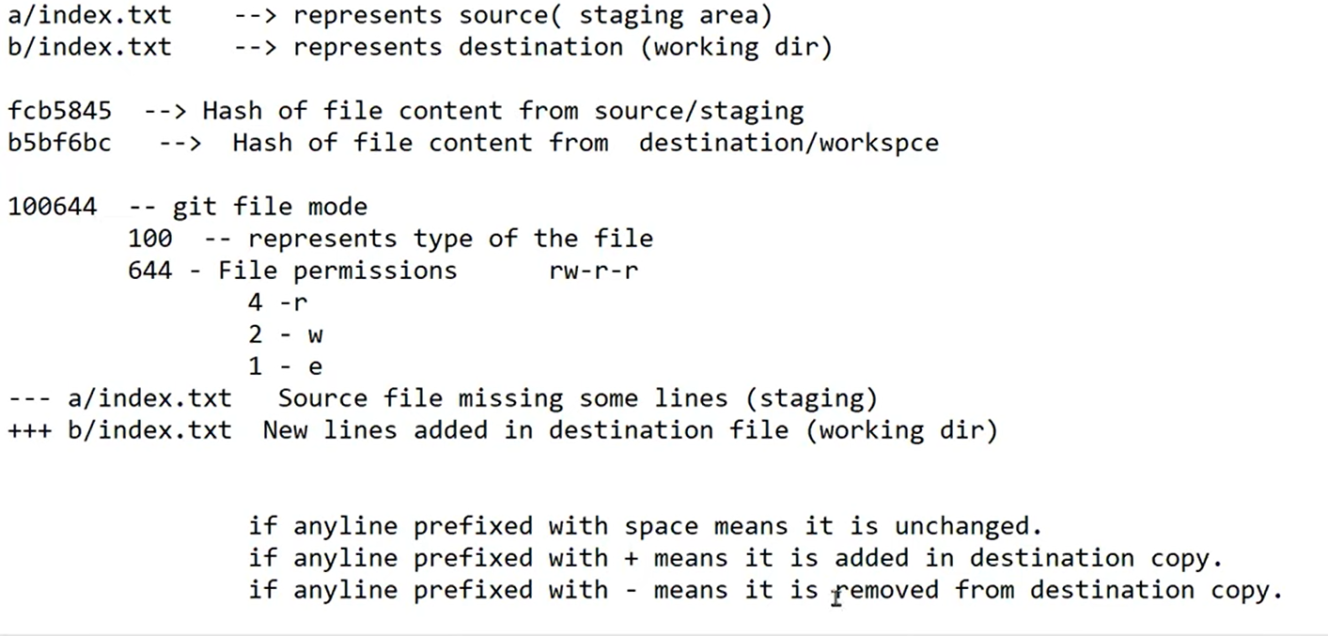

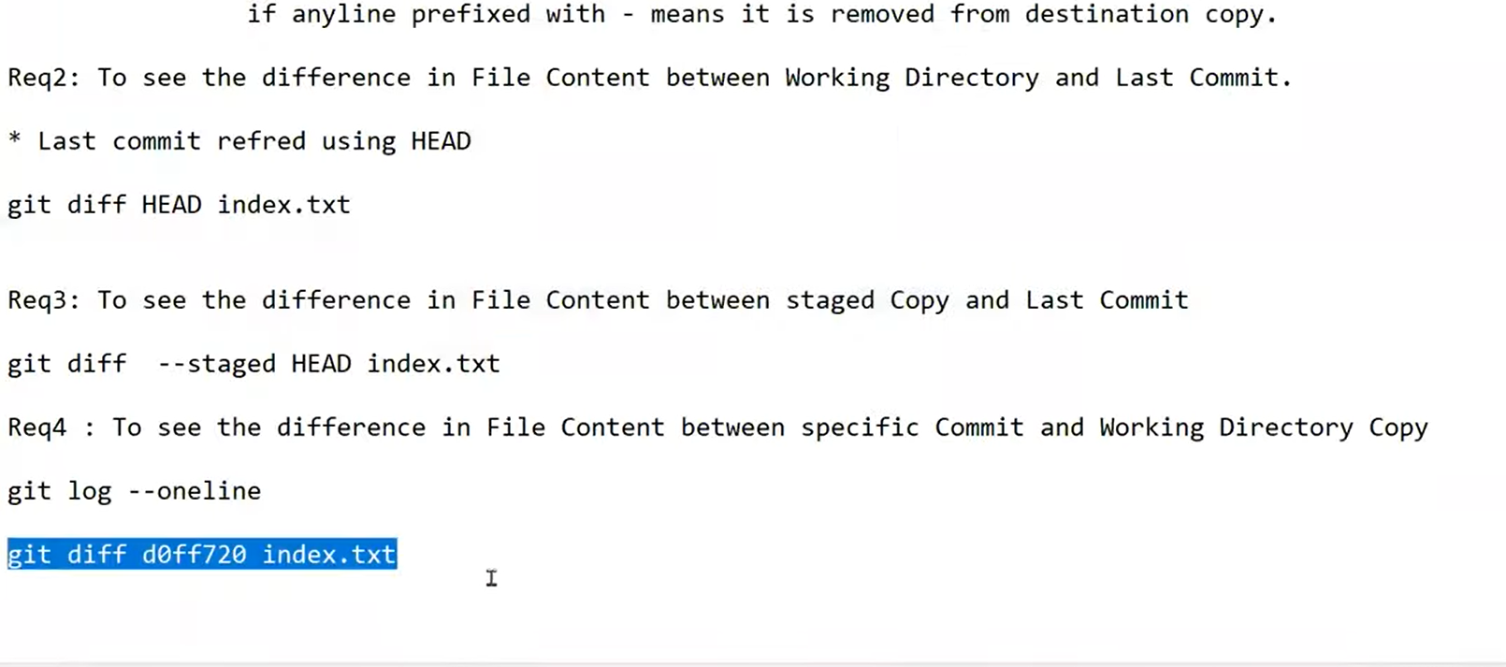

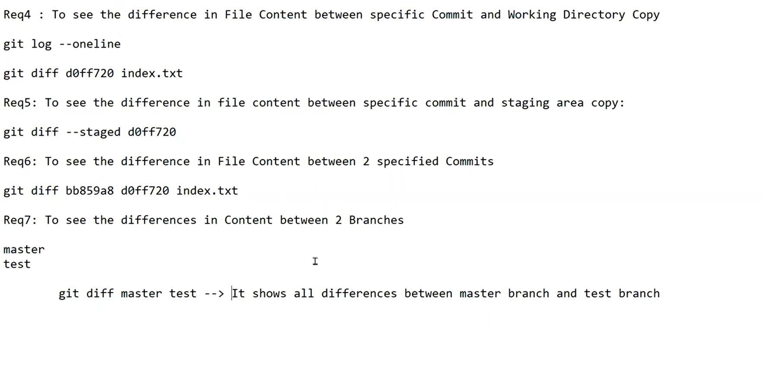

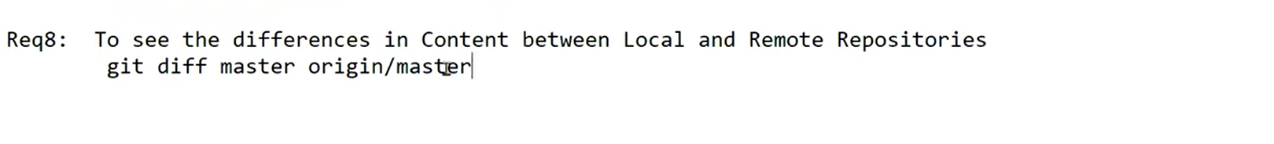

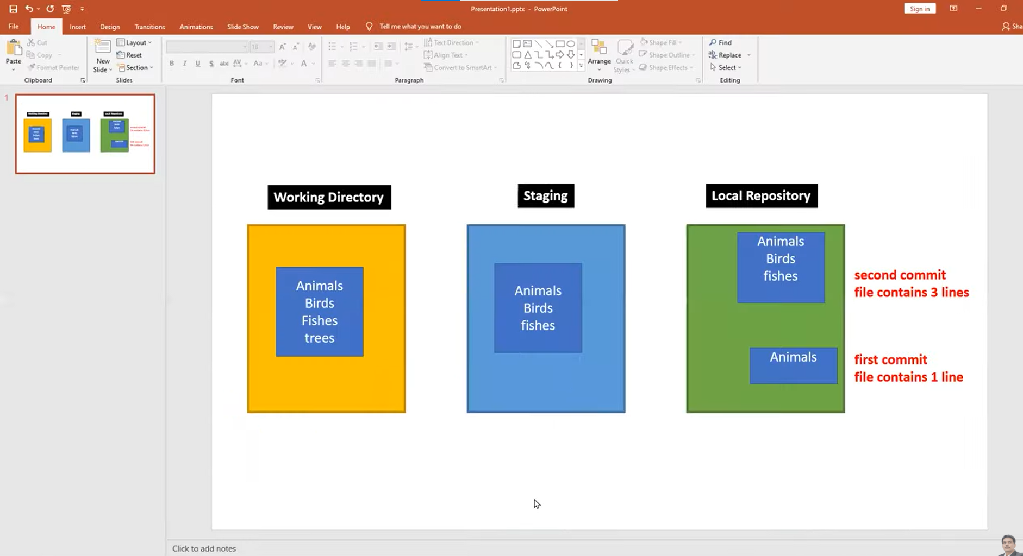

**GIT rm command:**

Rm is used to delete files from working directory or staging or local Repository

Or we can delete from both working directory as well as staging .

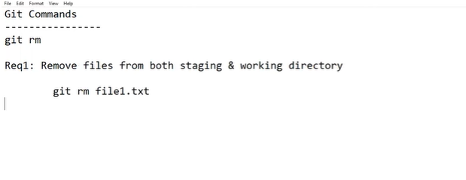

Before removing

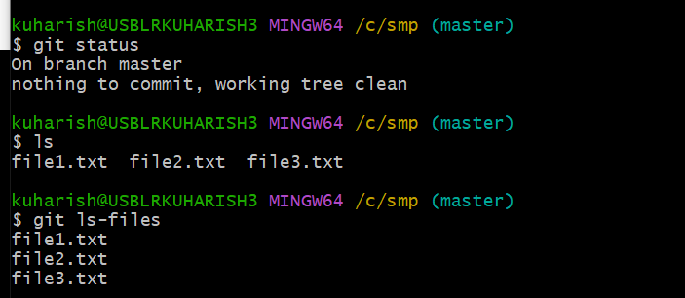

After removing using rm command

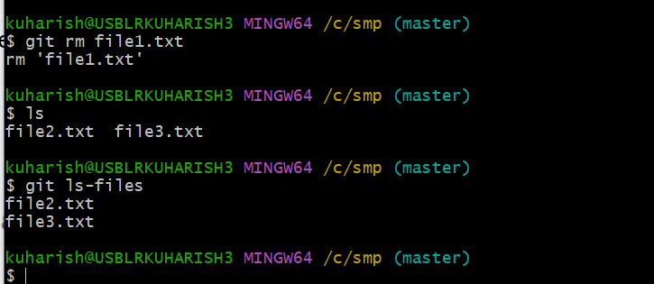

Git rm -r . = it will remove all files from working directory and staging.

Git ls : it will show all files in working directory

Git ls-files : it will show all the files in staging

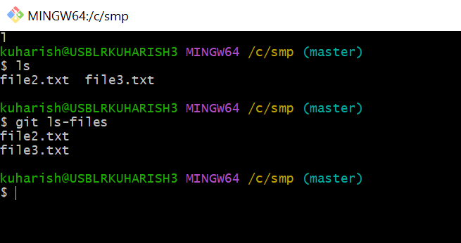

Remove files from only from staging

git rm - -cached file2.txt

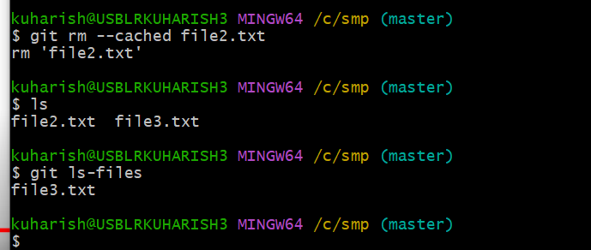

Remove files from only from working directory

rm file3.txt

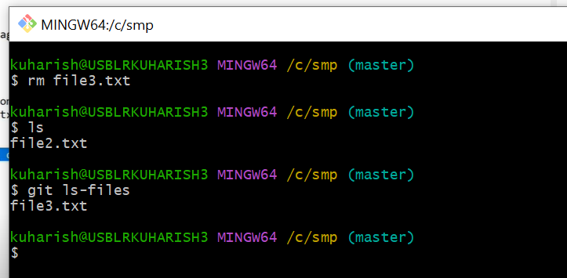

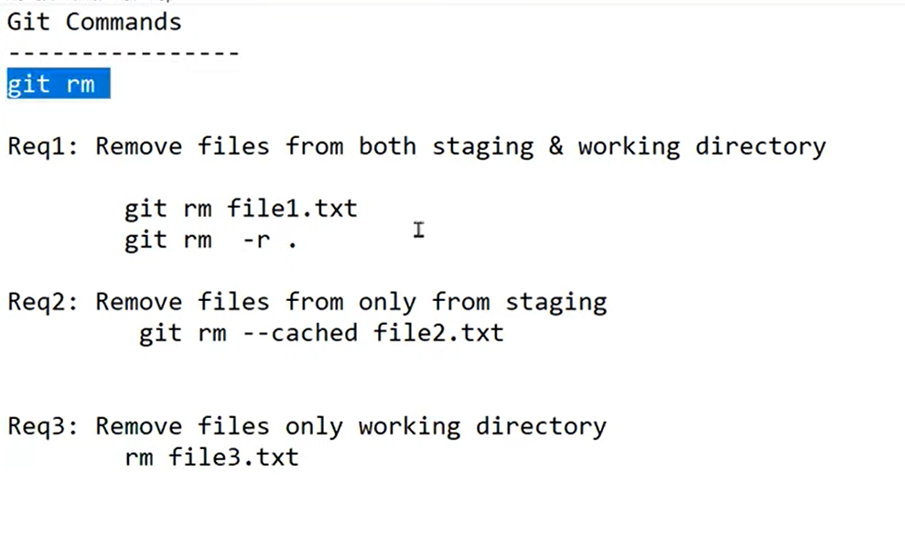

**GIT checkout:**

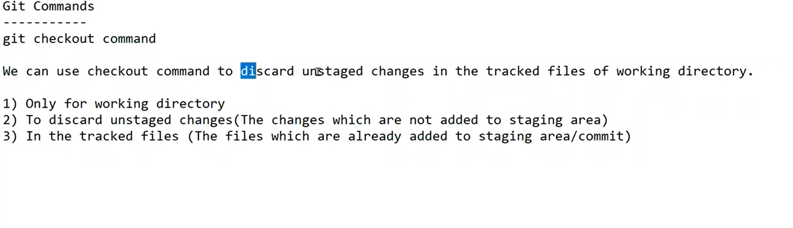

**Git checkout command worked only tacked files(means the files already present in staging and local repository)**

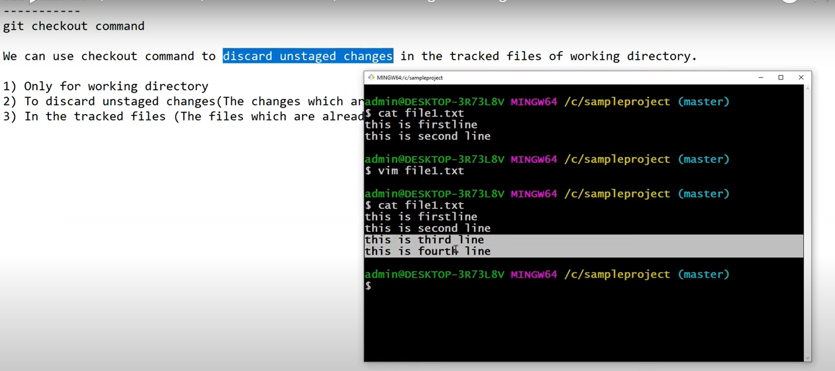

**This is third line**

**This is fourth line** this are unstaged changes if u want discard/ remove this line we will use checkout command.

**git checkout –file1.txt**

**After using check out command to remove unstaged changes**

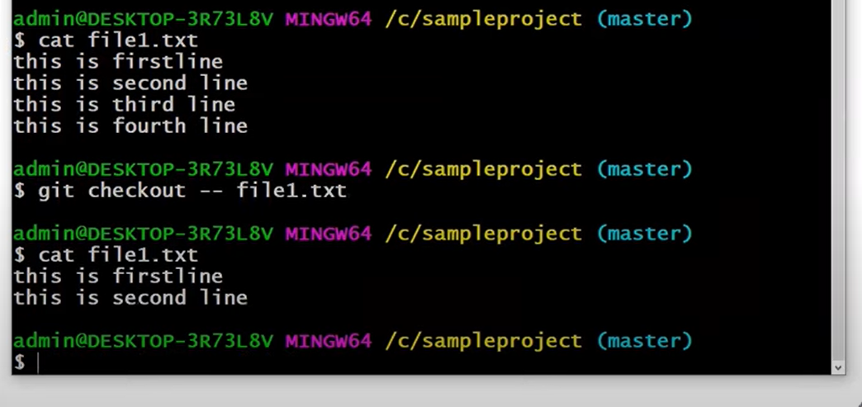

If we use checkout command for untracked files it will show following error

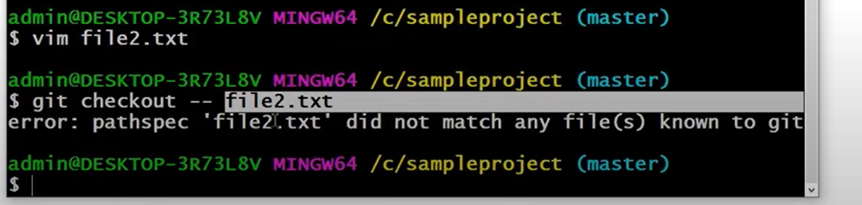

To check the data in file we use

Cat file1.txt

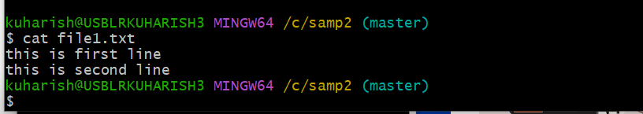

**Git reset :   
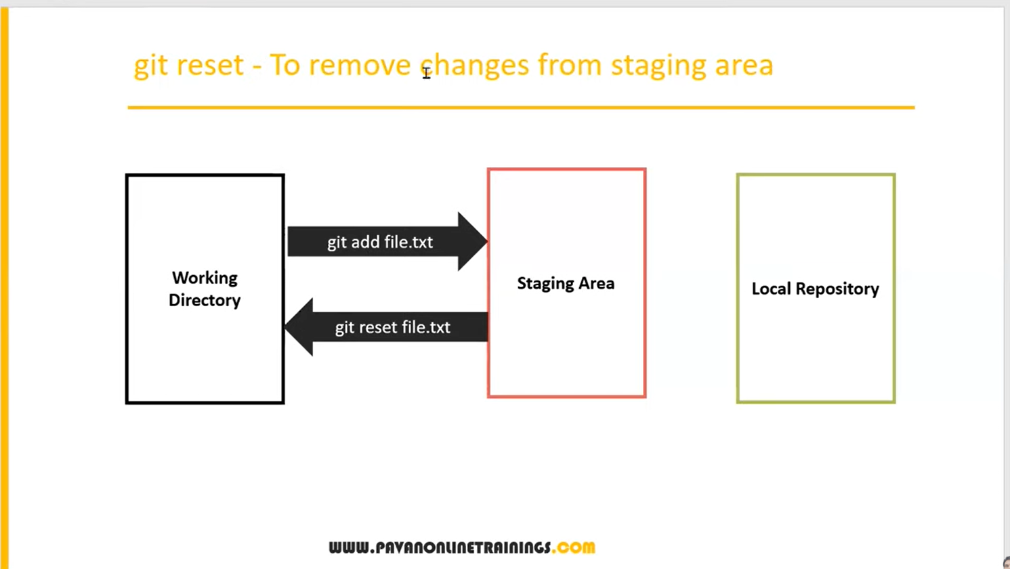**

Git reset index.txt, here we removed index.txt file from staging area.

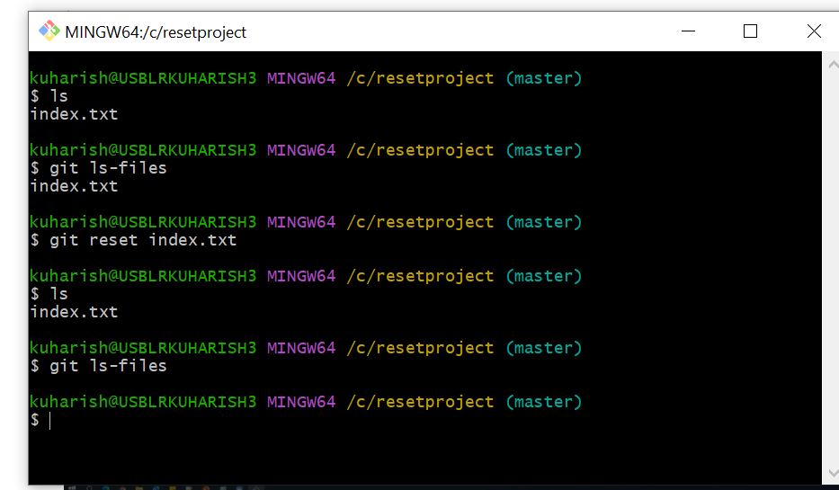

Reset command will do at repository level is which will undo the changes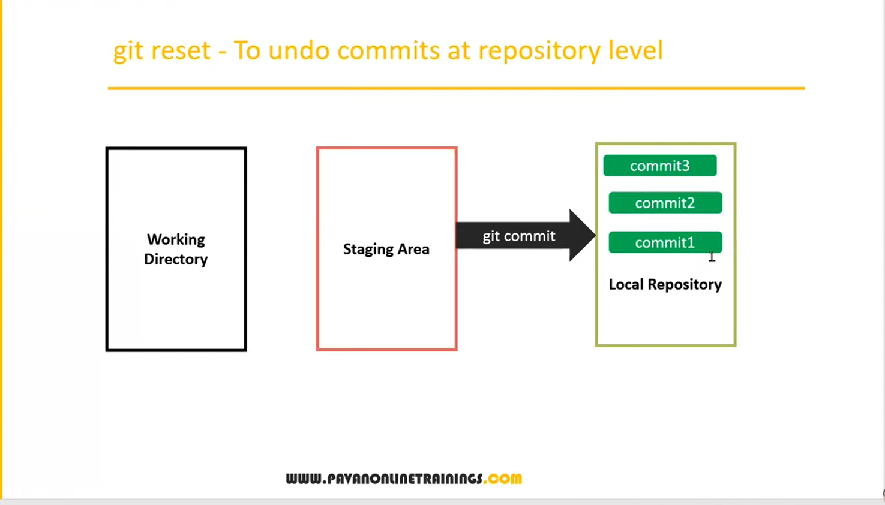

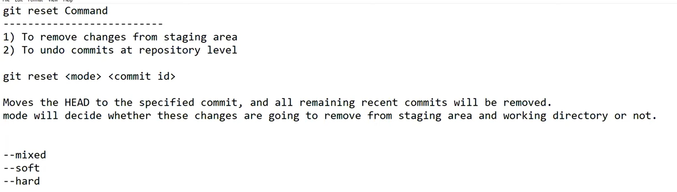

We can see all logs(commites) in one line we will use below command

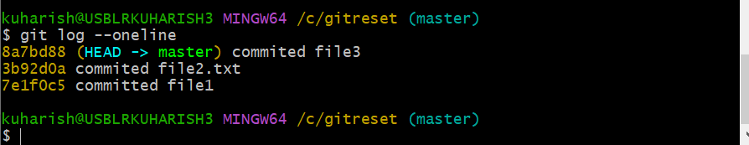

Here HEAD refers the latest commit

Git reset –mixed commit id

If we pass any commit id here the above committees are discarded/removed

Suppose

5

4

3

2

1

5 commits you have , if you pass commit number 3 it will remove 4 and 5 commit changes.

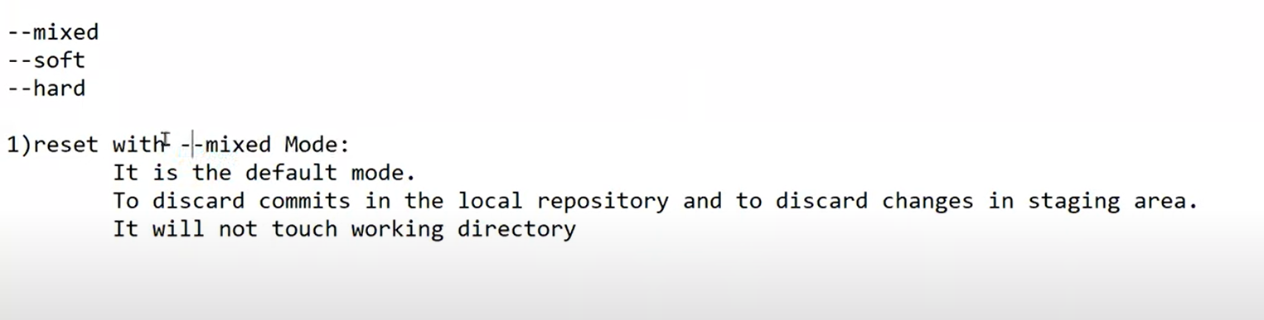

In below diagram

Before using

$ git reset --mixed 3b92d0a

this commit id will be present in both all 3 place working directory and staging , local repository

after using

$ git reset --mixed 3b92d0a

It will remove that git commit from local repository and staging area.

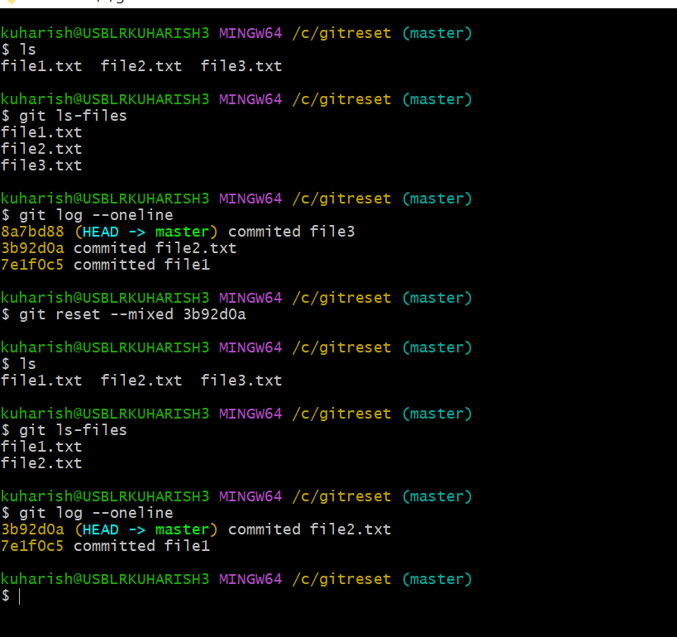

Mode2

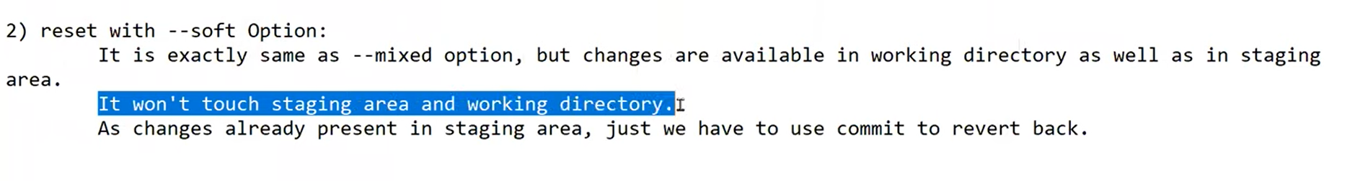

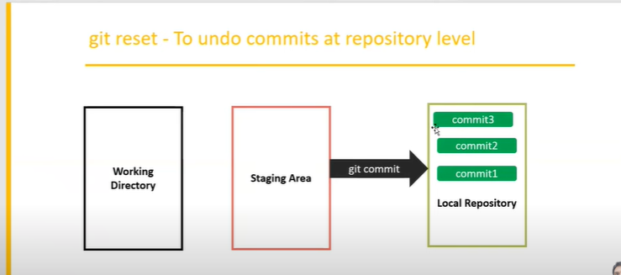

Here below after using $ git reset --soft 3b92d0a

The files are still present in staging and working directorty

Only commit it will removed.

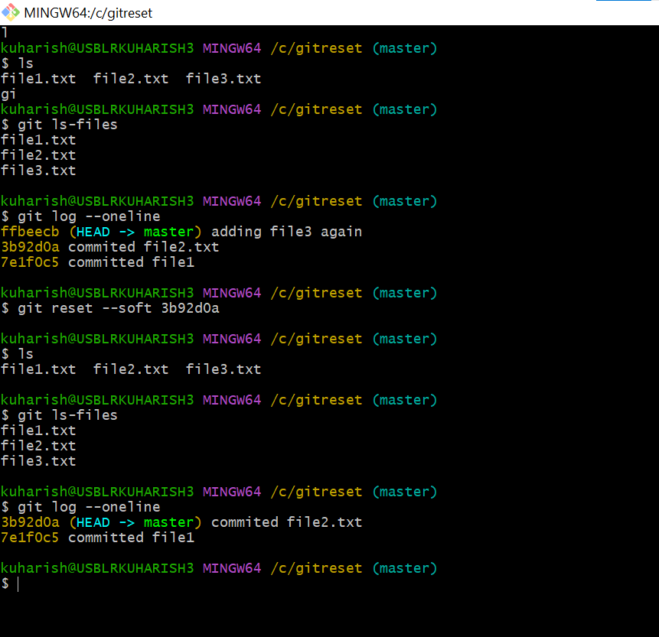

Mode 3

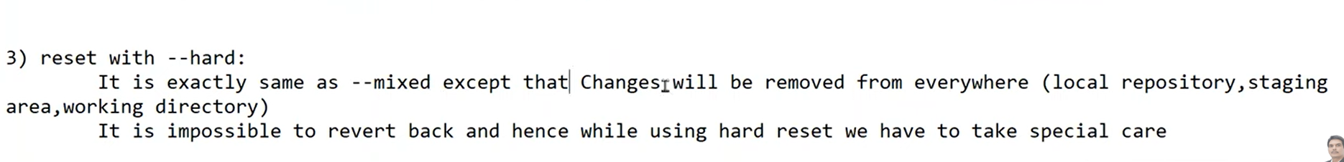

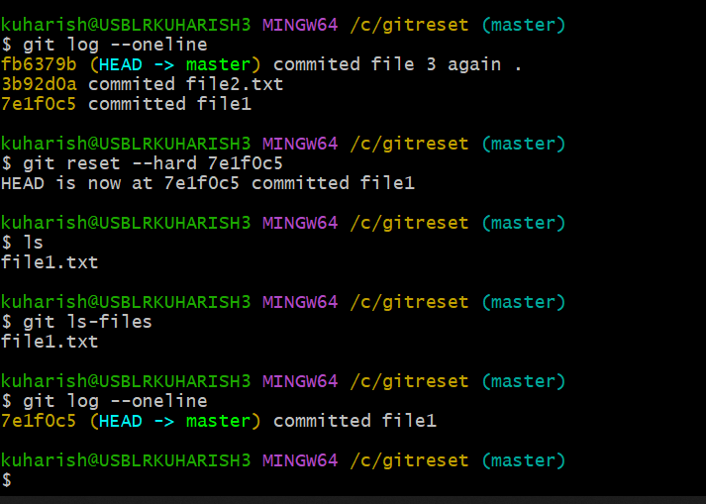

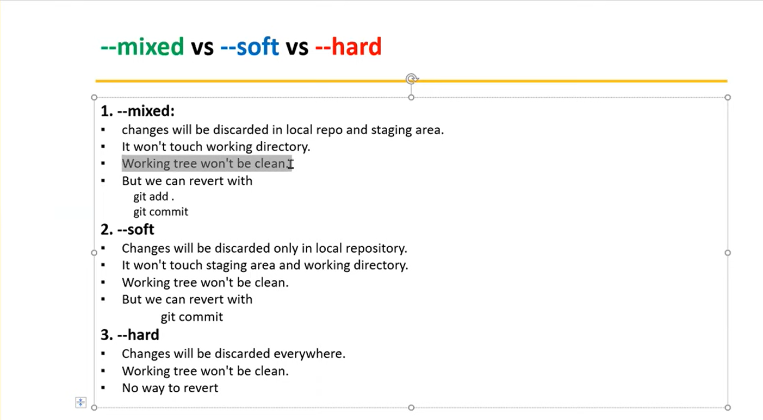

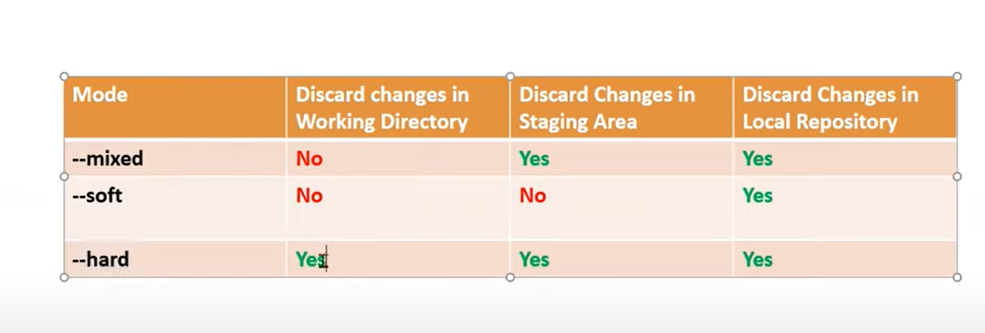

**GIT Branching :**

Git branching is used to develop the Parelle development

-and we have clean code , without disturbing the main source code, create multiple branches

And implement the what ever the feature allocated , after compltetion of the feature , we can merge that code into main branch or we can directly push the code into remote repository.

Sub-branches inherit all the code from main branch

Every branch in git are independent/isolated.

We can create n number of sub-branches

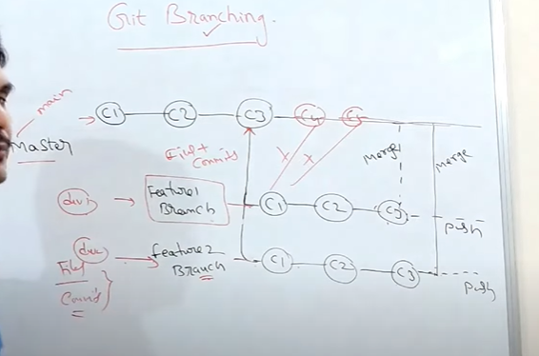

code from different developers’ different features

Here we will create new sub branch from main branch

Inside sub branch we will add all the latest code and featues finally we will add this

Sub-branch code/featues we can push directly to remote repository or we will merge the sub-branch to main branch.

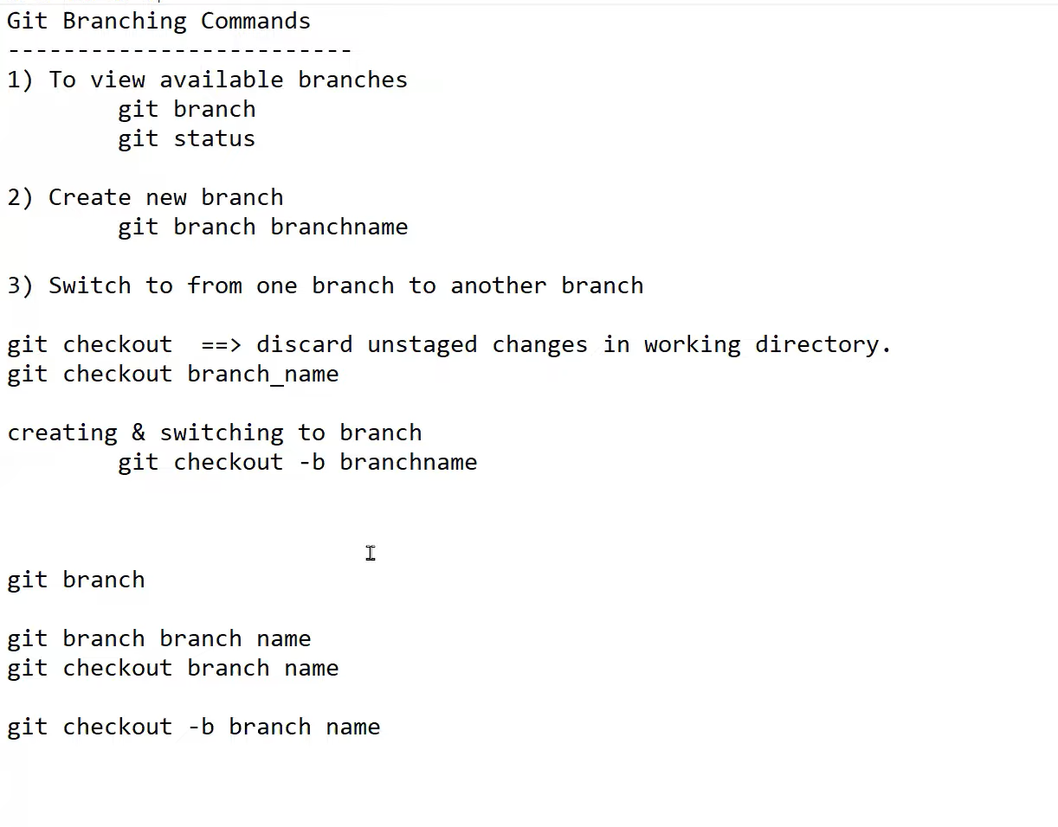

Git branch= it will show you all the branches available.

Git branch branch name = it will create new branch name

Git checkout branch name= to switch to particular branch .

Git checkout -b branch name = it will create new branch and switch to new branch at atime.

Below

kuharish@USBLRKUHARISH3 MINGW64 /c/gitproject (master)

$ git branch

br1

* master

Here * represent current branch name.

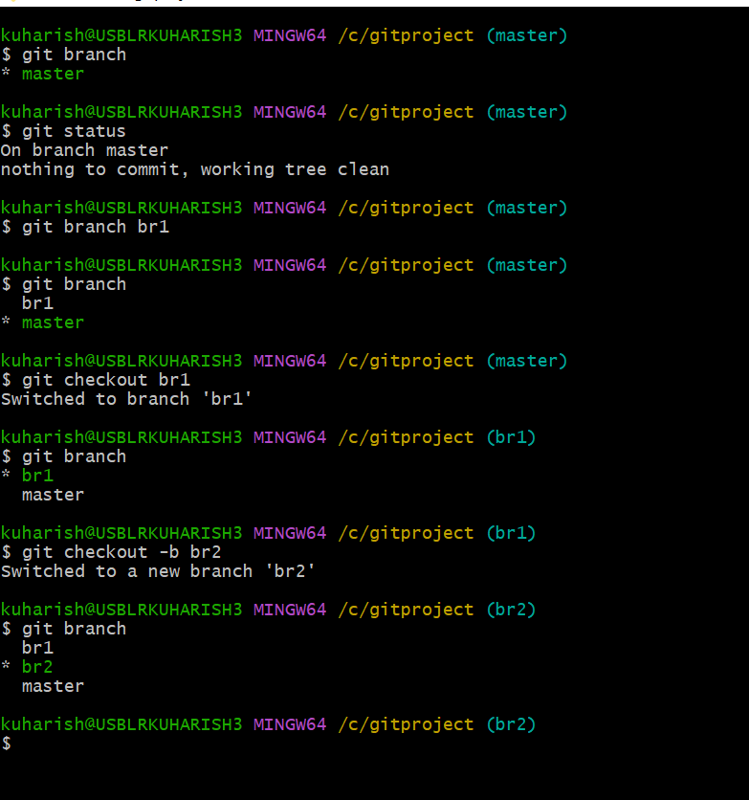

Note:

1)once you create any new branch what all are files commits which already done in the parent branch which will be inherited into child branch.

2) in the child branch what ever we created , we can create new files are we can changes file we can do n number of commits , it will directly not impact on the main branch.

3) all branches are isolated i.e every branch is independent.

4) once the work is completed on any particular branch we can push into remote repository directly or we can merge those change into master branch.

**After creating /inheriting main branch to sub- branch:**

If we add new files into sub-branch(br1) it will not impact to main branch same as vice versa

If we add new files into main branch it will not impact to child(sub-branches).

All branches are independent or isolated.

**Merging:**

When you do parallel development , when you complete the feature branch that code will be combined with master branch

**There are two ways to merge.**

**Fast-forward merge:** without disturbing the master(main) branch we will do changes in child branch and finally we will merge the code into master branch.

**Three-way merge :** here we are changes doing in master branch parallelly we Are doing changes(add features , modify, delete) in child branch.

Here merge commit will created at the end by git.

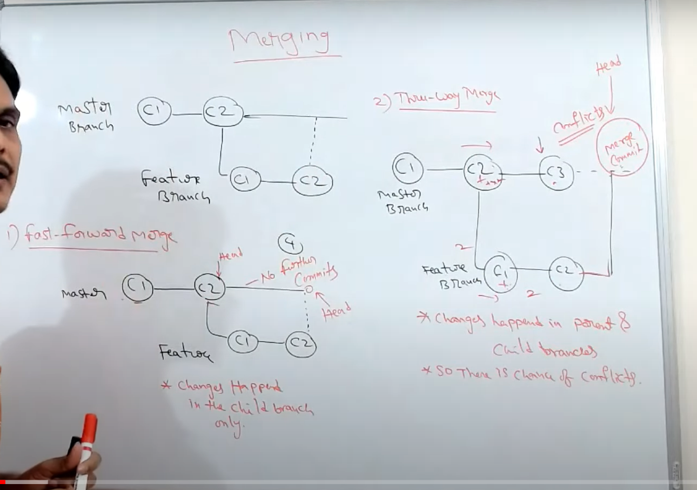

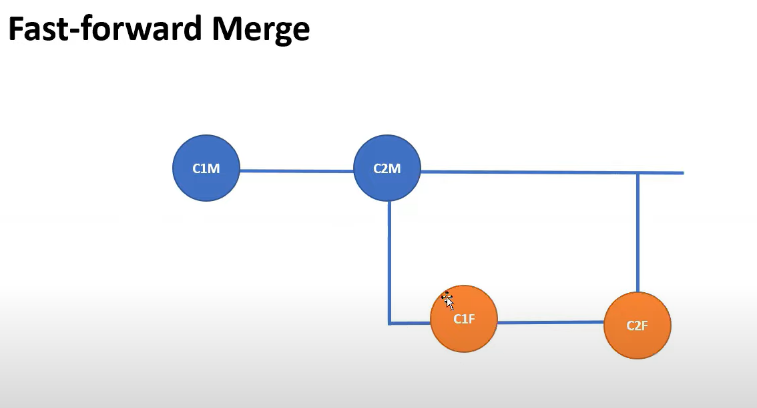

Here while merging we need to switch to master branch then we will do merging.

In fast forward merge there is no chance of conflicts because there is no changes in the master/parent branch.

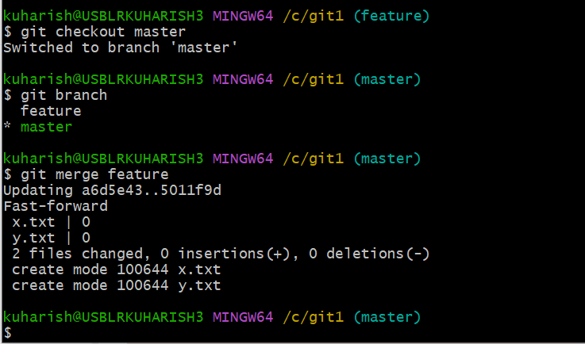

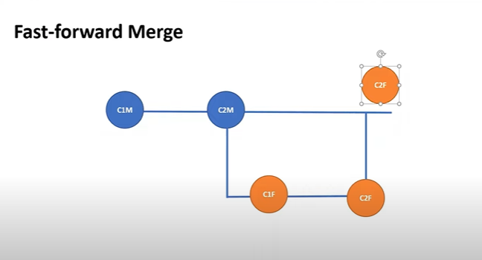

Three way merge

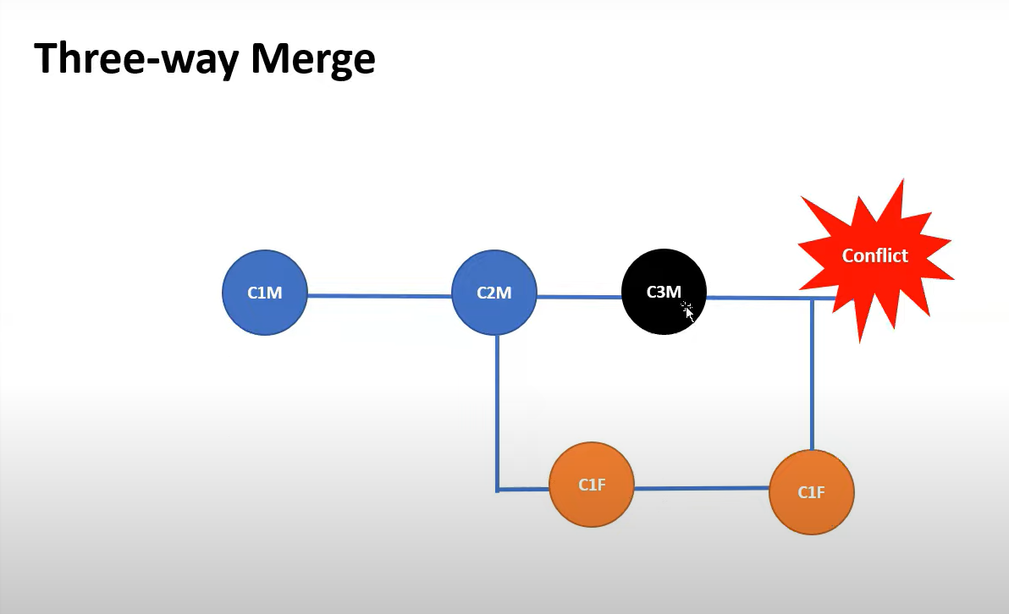

Here confilict will be occurs, if you change the code/modification of parent branch file in child branch after inhering then confilict will occur b/w child branch files and parent branch files.

If you do any changes in existing file there must be conflict will occur.

If you don’t do any changes in existing files so there will be no conflict .

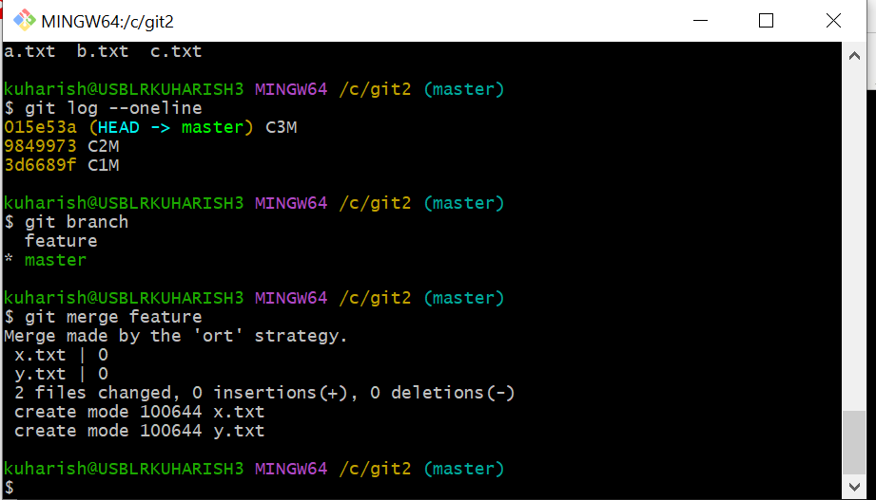

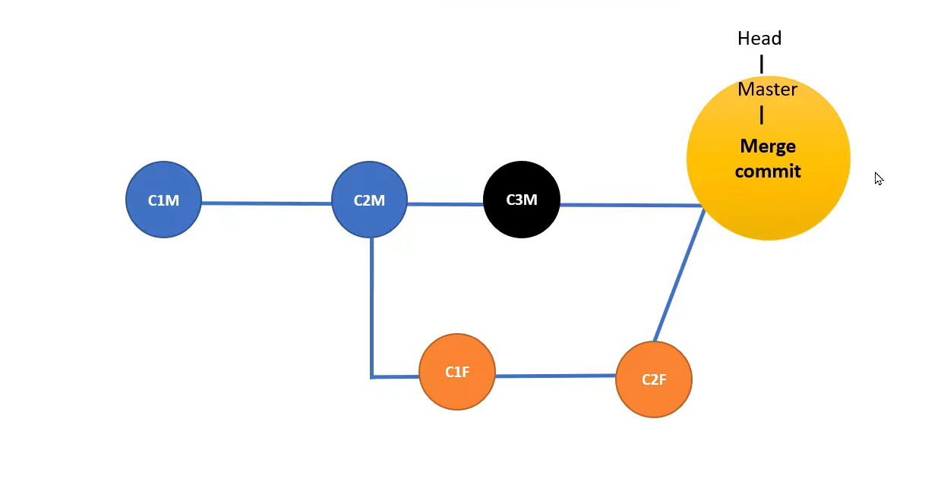

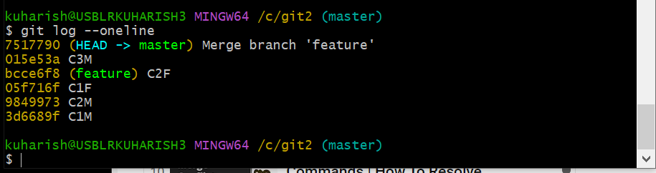

kuharish@USBLRKUHARISH3 MINGW64 /c/git2 (master)

$ git log --oneline

7517790 (HEAD -> master) Merge branch 'feature' = this commit is created by GIT

015e53a C3M

bcce6f8 (feature) C2F

05f716f C1F

9849973 C2M

3d6689f C1M

Once we will merge the child branches into main /parent branch we can remove child branch .

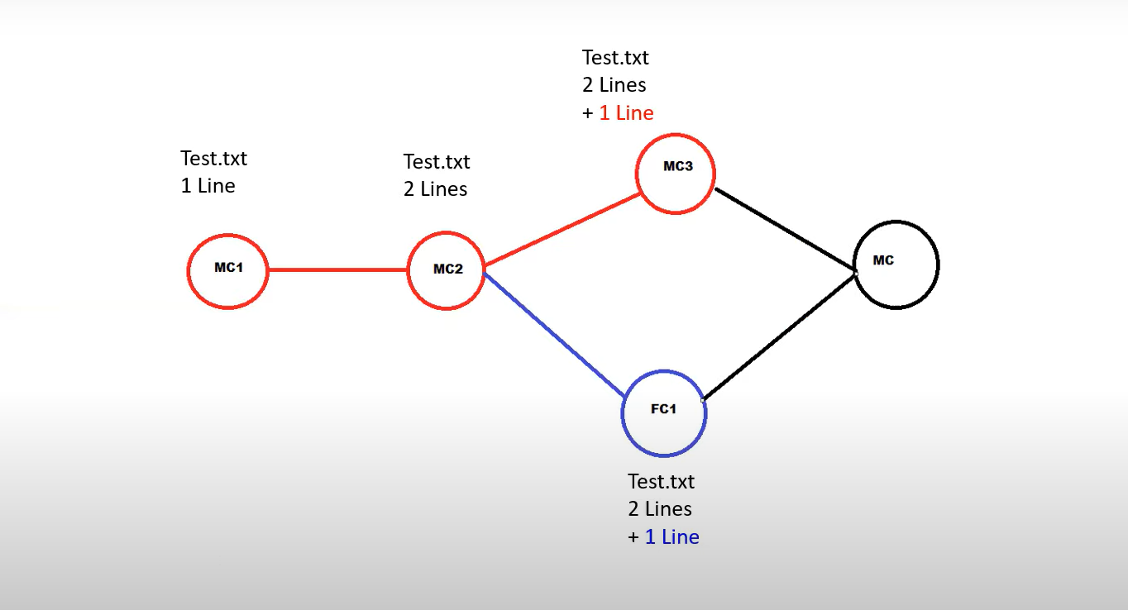

To delete child branch or any branch

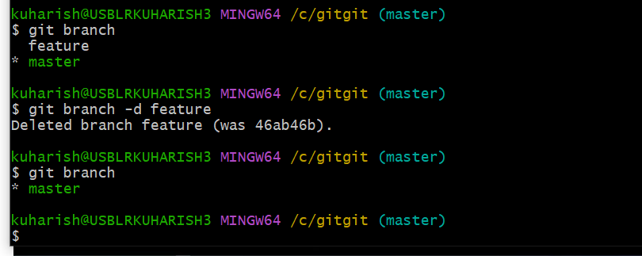

**Git rebase:**

Rebase is the alternative of merge

In git rebase it is also follow the three way merge, but here there is no conflict the code.

When we use merge and rebase

Merge is we can go with every time suppose there is conflict or no conflict

After that we can push our code into remote repository.

Don’t use rebase for remote repository.

Rebase is not recommended when you push the code into remote repository.

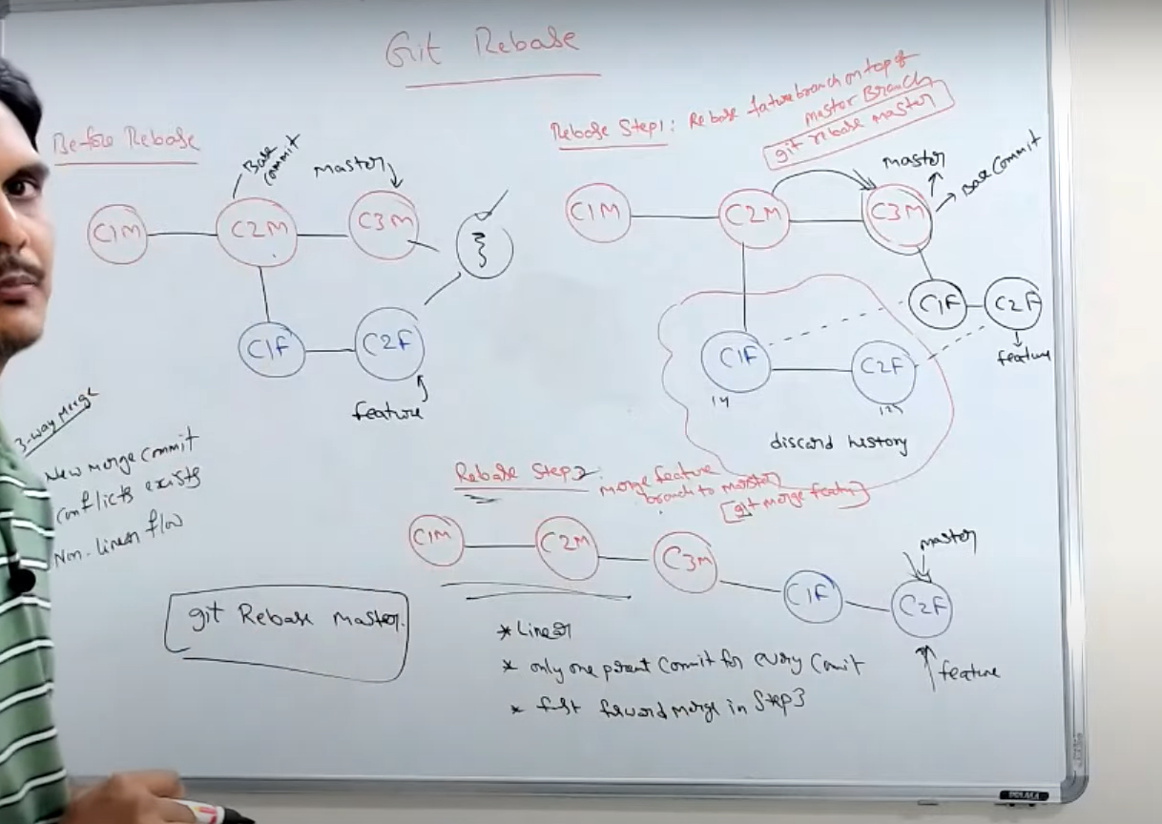

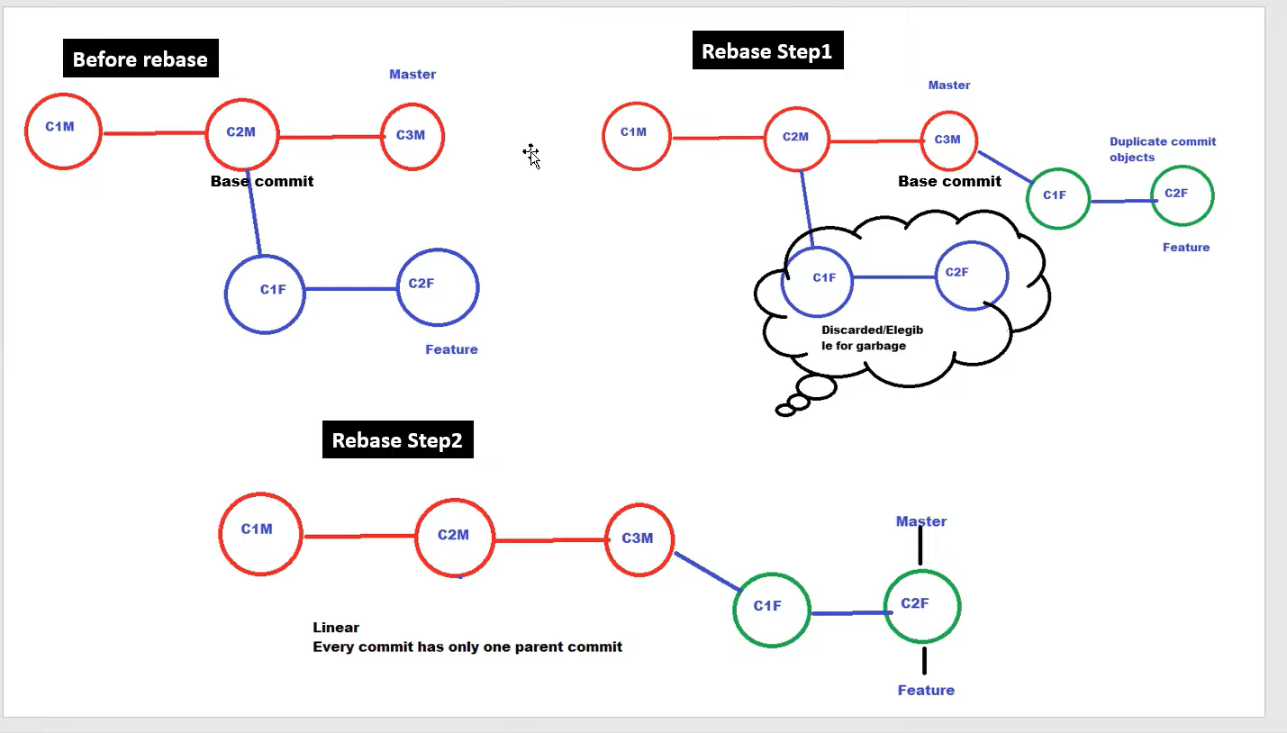

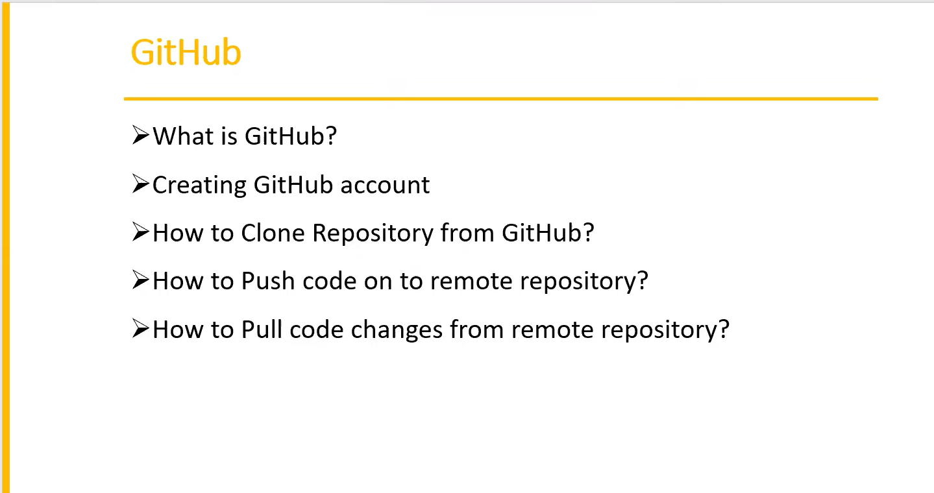

What is git:

Git is a local repository , so we can create local repository , branches , we can mergers the branches we can resolve the conflict everything we will do in our local machine.

What is github:

Github is a remote repository

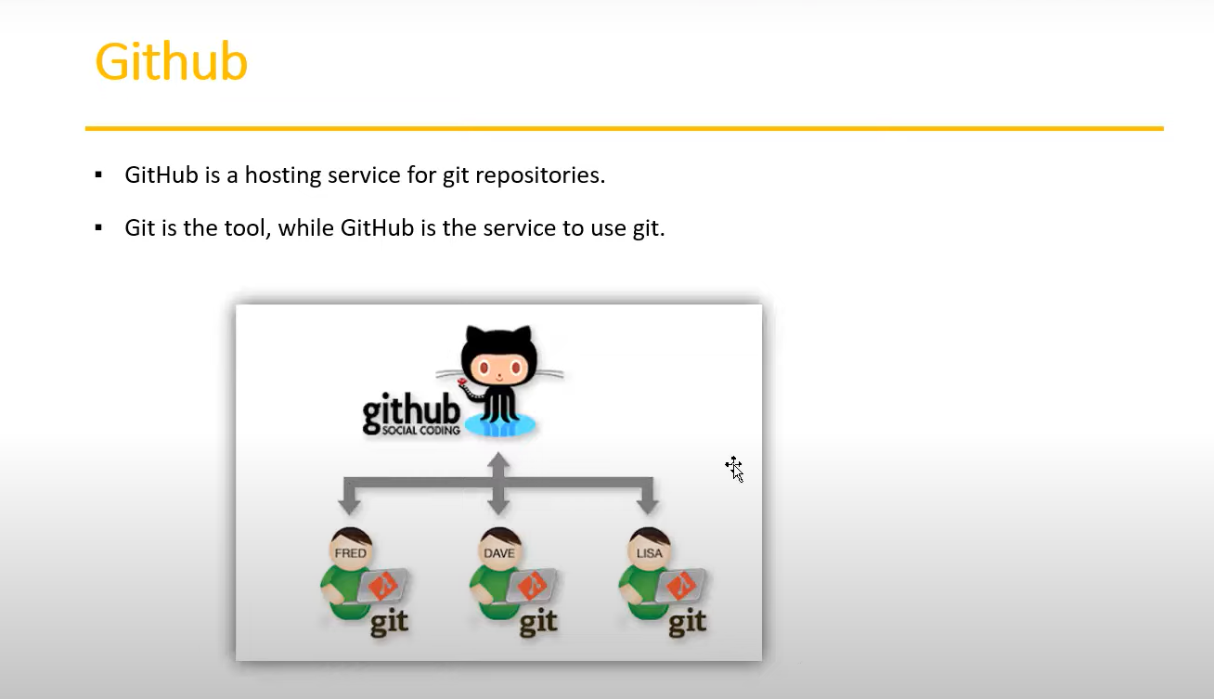

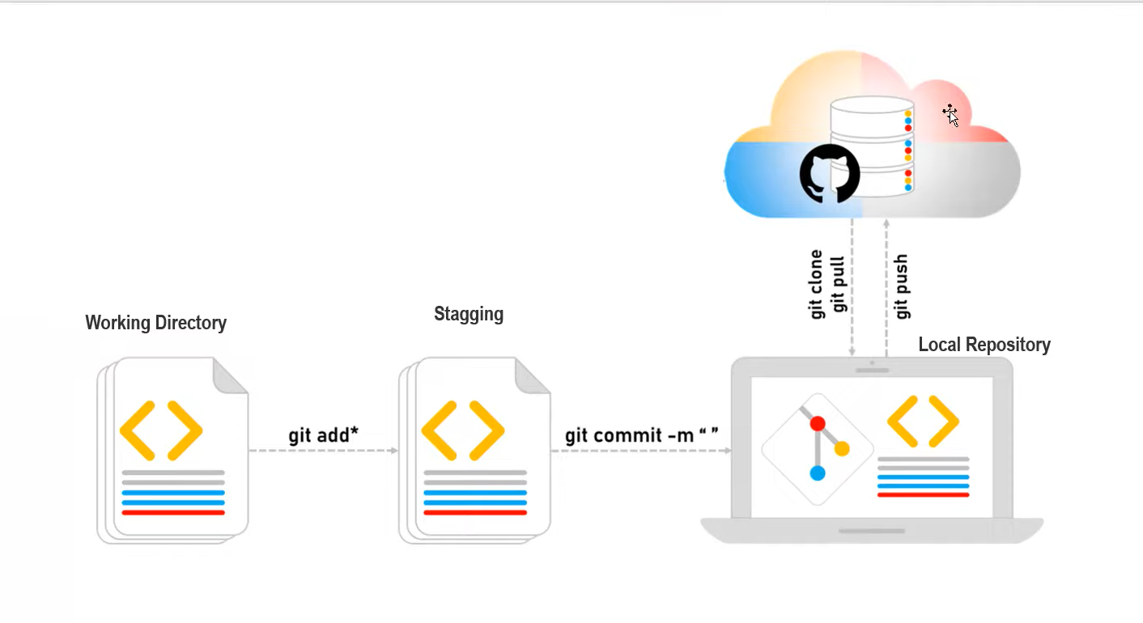

Git clone : in git hub there already some repositories are available remote repository, to get that remote repository into your local machine we will use git clone.

Git push : to push your local repository /local machine code into remote repository we will use git push command.

Git pull : git pull command will pull all the latest files which already available in the remote repository into your local repository.

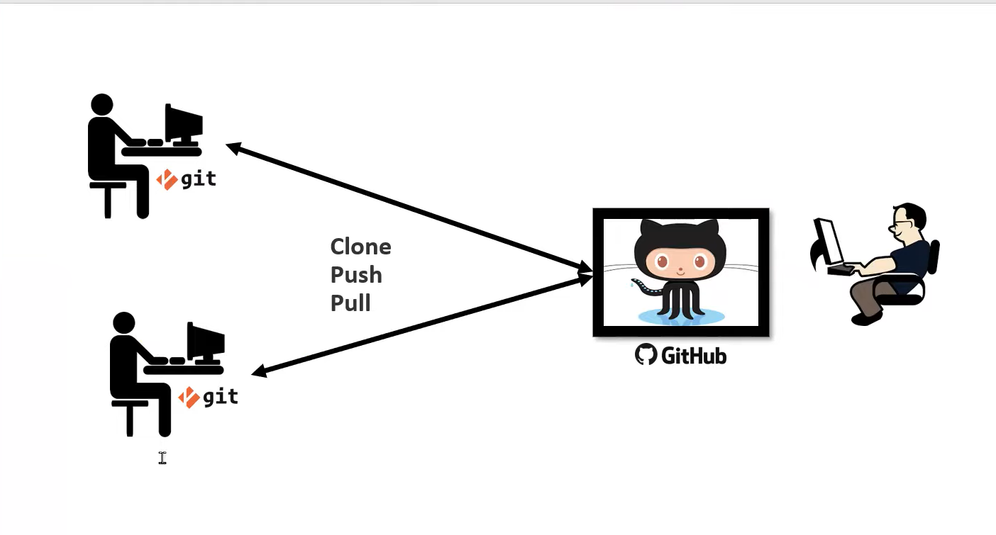

To clone the data from repository

kuharish@USBLRKUHARISH3 MINGW64 /c/gitproject

$ git clone 'https://github.com/KummaraHarish/testrepo.git'

Cloning into 'testrepo'...

remote: Enumerating objects: 3, done.

remote: Counting objects: 100% (3/3), done.

remote: Compressing objects: 100% (2/2), done.

remote: Total 3 (delta 0), reused 0 (delta 0), pack-reused 0

Receiving objects: 100% (3/3), done.

To push local repository to remote repository(git hub)

kuharish@USBLRKUHARISH3 MINGW64 /c/gitproject/testrepo (main)

$ git push orgin main

fatal: 'orgin' does not appear to be a git repository

fatal: Could not read from remote repository.

Please make sure you have the correct access rights

and the repository exists.

To take latest code from remote repository

kuharish@USBLRKUHARISH3 MINGW64 /c/gitproject/testrepo (main)

$ git pull origin main

remote: Enumerating objects: 5, done.

remote: Counting objects: 100% (5/5), done.

remote: Compressing objects: 100% (3/3), done.

remote: Total 3 (delta 0), reused 0 (delta 0), pack-reused 0

Unpacking objects: 100% (3/3), 707 bytes | 50.00 KiB/s, done.

From https://github.com/KummaraHarish/testrepo

* branch main -> FETCH_HEAD

c1528a6..7952751 main -> origin/main

Updating c1528a6..7952751

Fast-forward

myfile2 | 1 +

1 file changed, 1 insertion(+)